Google AI Essentials overview
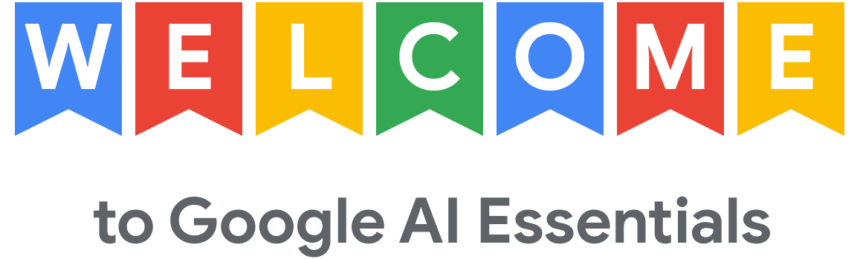
Ready to enhance your productivity and bring your best ideas to life? Artificial intelligence (AI) is quickly transforming today’s workplace, and developing a strong understanding of the technology can give you a competitive edge. Here, we teach you how to put AI to work for you.
It's designed for professionals across all industries—no experience required. You'll get hands-on experience using generative AI (gen AI), a specific type of AI that can create new content like text, images, video, code and more. By learning to use gen AI, you can tackle routine tasks more efficiently, get creative inspiration, and enhance the quality of your work.

What you'll learn
The Google AI Essentials consists of five courses:
- Introduction to AI (current course): Discover how AI works and explore foundational AI concepts, such as machine learning. Learn about the rise of generative AI and how to perform tasks with it. By the end of this course, you’ll have an understanding of the capabilities and limitations of AI tools and how to integrate generative AI in the workplace.
- Maximize Productivity With AI Tools: Leverage generative AI tools to speed up work tasks and boost your productivity. Examine the important role humans play in the effective use of AI, and understand the types of workplace tasks you can augment with AI. By the end of this course, you will be able to determine if AI is right for a given task and how to use AI to accelerate workflows.
- Discover the Art of Prompting: Write effective prompts to get the output you want. Learn how to incorporate prompting techniques, such as few-shot prompting, into your work. Understand how generative AI tools produce output and the importance of evaluating output before using it. By the end of this course, you will be able to write clear and specific prompts and produce outputs that help accomplish workplace tasks.
- Use AI Responsibly: Use AI responsibly by mitigating unfair biases and inaccuracies. Learn how to apply a framework of AI harms to sample workplace scenarios and recognize the security risks of using AI in the workplace. By the end of this course, you will gain an understanding of how to use AI responsibly and effectively, and a checklist to help you do it.
- Stay Ahead of the AI Curve: Continue developing your skills within the current and emerging AI landscape. Learn about the ways organizations have leveraged AI and consider how these innovations may inspire your own AI-powered workplace solutions. By the end of this course, you will develop a strategy to stay up to date with future AI developments.

How you learn
Each of the five courses offers a variety of content, including:
- Videos taught by AI experts at Google who share new concepts and guidance.
- Readings to deepen your understanding and spark ideas about how to use AI.
- Activities that help you practice the skills you are learning.
- Dialogues with Coursera's Coach, an AI-powered learning assistant.
- Graded quizzes to measure your progress and give you meaningful feedback. If needed, you can take a graded quiz multiple times to achieve a passing score of 80% or higher.
When you complete all courses of AI Essentials, you'll earn a certificate from Google that you can share on social networks or add to your resume.


